
New… From Hummingbird Med…..
The Only Umbilical Catheter with Integral Low Volume Closed Blood Sampling System
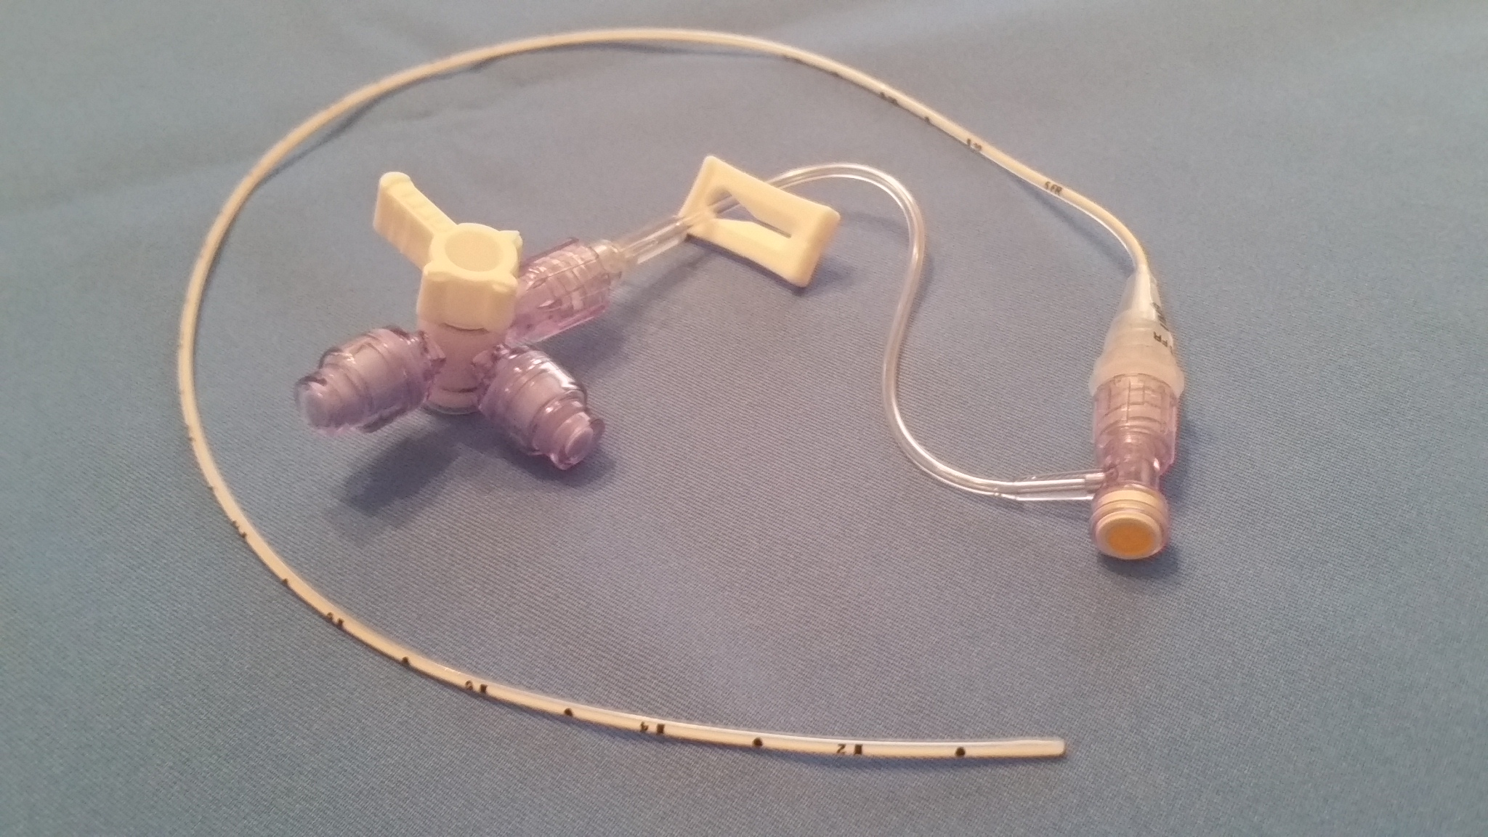
Reduced Infection Risk and Lower Risk for IVH Development during UAC Blood Sampling
Closed Port System
- Provides an integral closed system for UAC Blood Sampling from the time of initial line placement
- Closed access through the Micro T split-septum with microbial barrier; allows sampling directly from UAC catheter hub utilizing the Hummi Micro-Draw Device
- Allows for lowest volume clearance of any blood sampling system, 0.5mL and lowest flush volume, 0.3mL
- Provides best practice infection control with closed port arterial line change and closed port flushing
Reduced Risk for Alteration in Cerebral Blood Flow and Hemodynamic Change in the Neonate, Now Shown to Contribute to IVH Development
- One of the strongest risk factors that demonstrate an increased risk for IVH/PVL is the use of umbilical catheters in the neonate. *1 This risk is primarily due to current blood sampling methods
- Using the UAC with Integral Closed Blood Sampling System and the Hummi Micro-Draw Device provides a 70% reduction in overall blood/fluid movement required for UAC blood sampling
- Overall blood/fluid movement during UAC blood draw of 4mL to 6mL is reduced down to 1.3mL
- Clearance volume for UAC blood draw is reduced to only 0.5mL
- Reduced flush volumes for UAC after sampling to 0.3mL, contributing to more stable sodium values

Improves Line Maintenance
- UAC Catheter with Closed Blood Draw System pre-assembled for improved Infection Control
- Dual Port Device with integral valves provides closed line change port and closed flushing port
- Reduces risk of biofilm formation in arterial line due to blood contact and residual blood in line after blood sampling and flushing. * 2 No blood is drawn into the arterial line for sampling with this closed system
- Reduces air bubble issues and wave form damping by elimination of extra in-line components required for closed arterial blood sampling using existing methods
- No impact on wave form integrity from integral closed sampling system

High Quality Umbilical Catheter with Integral Closed Sampling System

UAC Catheter
- Highly visible French size and catheter type marking on catheter hub (fig 1) vs others (fig 2)
- Clear distinct markings on catheter for easy visualization during placement (fig 3)
- Highly radiopaque for placement confirmation
- Smooth rounded tip for reduced risk of vessel wall damage or perforation during insertion (fig 4)
- Available in Polyurethane and Silicone material

Integral Closed Blood Sampling System
- Utilizes the Micro T microbial barrier split-septum T-connector for direct access to Umbilical Catheter hub
- The Hummi Micro-Draw device provides access with a 1mm capillary size sterile blunt tube. A reduced portal size required for entry may reduce risk for bacterial ingress *3
- Only ONE access through the closed split-septum required for the entire blood draw procedure
- Provides a Dual Closed Port Device for a closed arterial line change and a closed flush port as recommended
by the Vermont Oxford Network for line setup and hub care for umbilical lines *4

1. Cath Size / Type Label  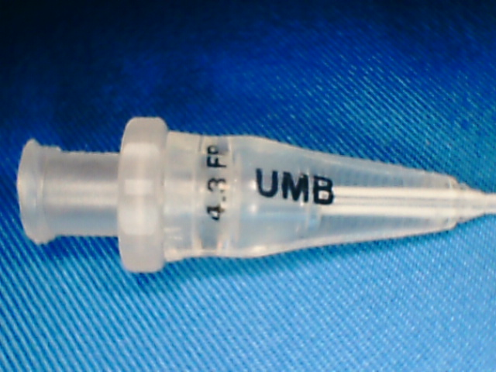 | 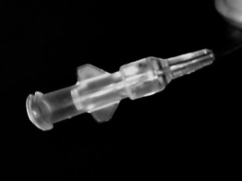  2. Other’s No ID Label | 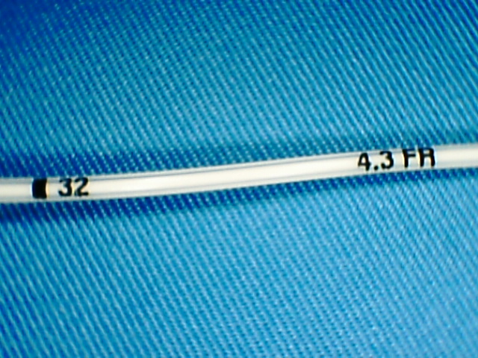  3. Distinct Depth Markings | 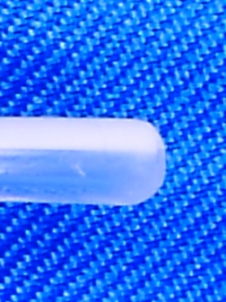  4. Smooth Rounded Tip
Umbilical Catheter with Integral Low Volume Blood Sampling System
Kit Description: Single Lumen, Sterile, Radiopaque Catheter with Radius Tip, Hummi Micro-Draw Device, Micro T Split-Septum T-Connector, Dual Port Device with Two Closed Port Silicone Valves All components Sterile, Latex Free, DEHP free, Non-Toxic
Ordering Information
Catalog | Description | Material | Qty | Catalog | Description | Qty
UAC-HM-50P | 5.0 fr. 32cm Polyurethane | PU | 5 / bx | ABG-HM-1 | Hummi Micro-Draw Blood Transfer Device | 50 / bx
UAC-HM-50S | 5.0 fr. 32cm Silicone | S | 5 / bx
UAC-HM-43P | 4.3 fr. 32cm Polyurethane | PU | 5 / bx | NMT8046 | Micro T Split Septum T-Connector | 100 / bx
UAC-HM-35P | 3.5 fr. 32cm Polyurethane | PU | 5 / bx
UAC-HM-35S | 3.5 fr. 32cm Silicone | S | 5 / bx | DPD-HM-2 | Dual Port Device with two integral silicone valves | 25 / bx
UAC-HM-25P | 2.5 fr. 25cm Polyurethane | PU | 5 / bx
Dual Lumen Configuration Available on Special Order
References: *1. J Korean Med Sci. 2010:418-24 *2. www.infectioncontrolresource.org: Resource Vol.4 No.2
*3. Ryder-Split-Septum-vs-Mechanical-Valve-APIC-2010 *4. PEDIATRICS Vol. 111 4 April 2003, pp. e519-w533

For additional information go to www.Hummingbirdmed.com LBL-027 rev1

